Experiment 1A: Auscultation
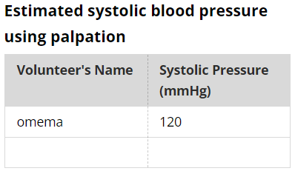
Stethoscope procedure
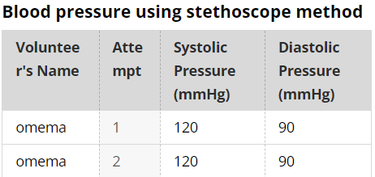
Experiment 1B: Blood Pressure and Finger Pulse
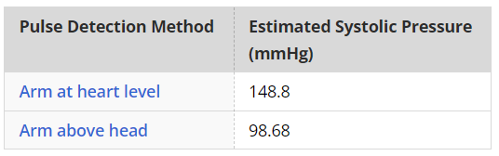
Experiment 1C: Cardio Microphone
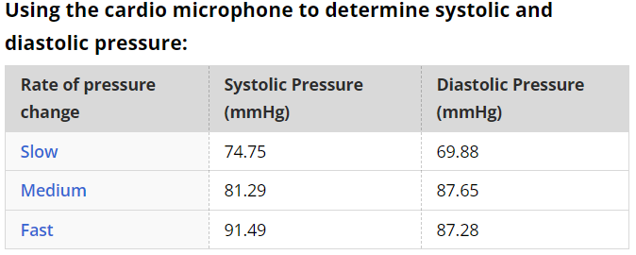

Experiment 1C: Cuff Size
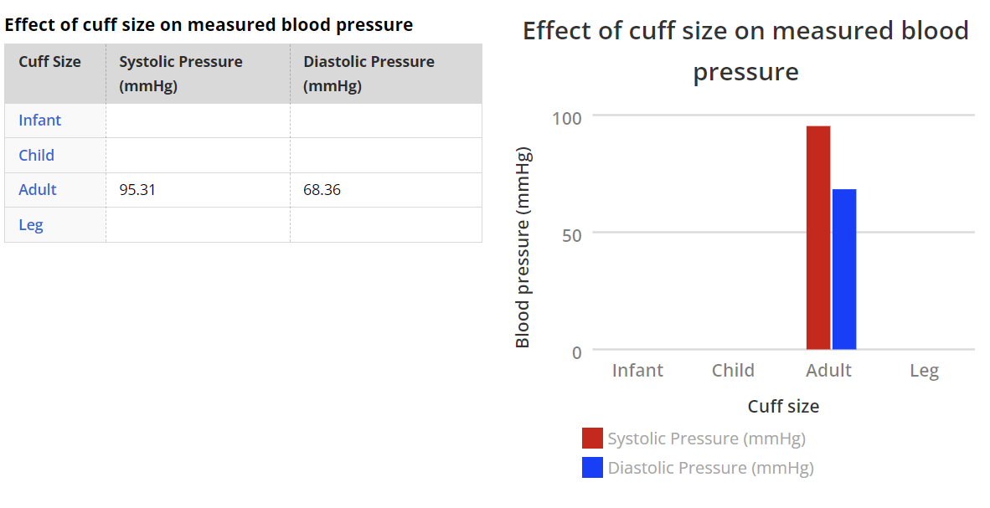
Experiment 1C: Arm Position
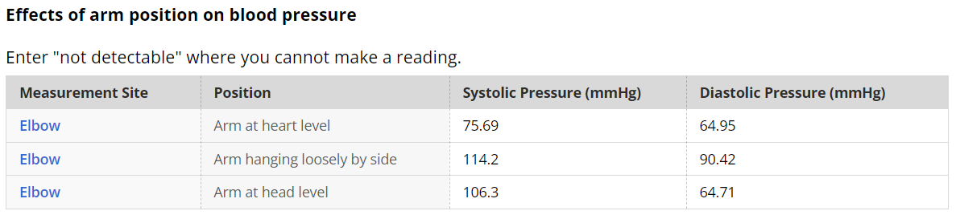
Experiment 1C: Leg Blood Pressure
